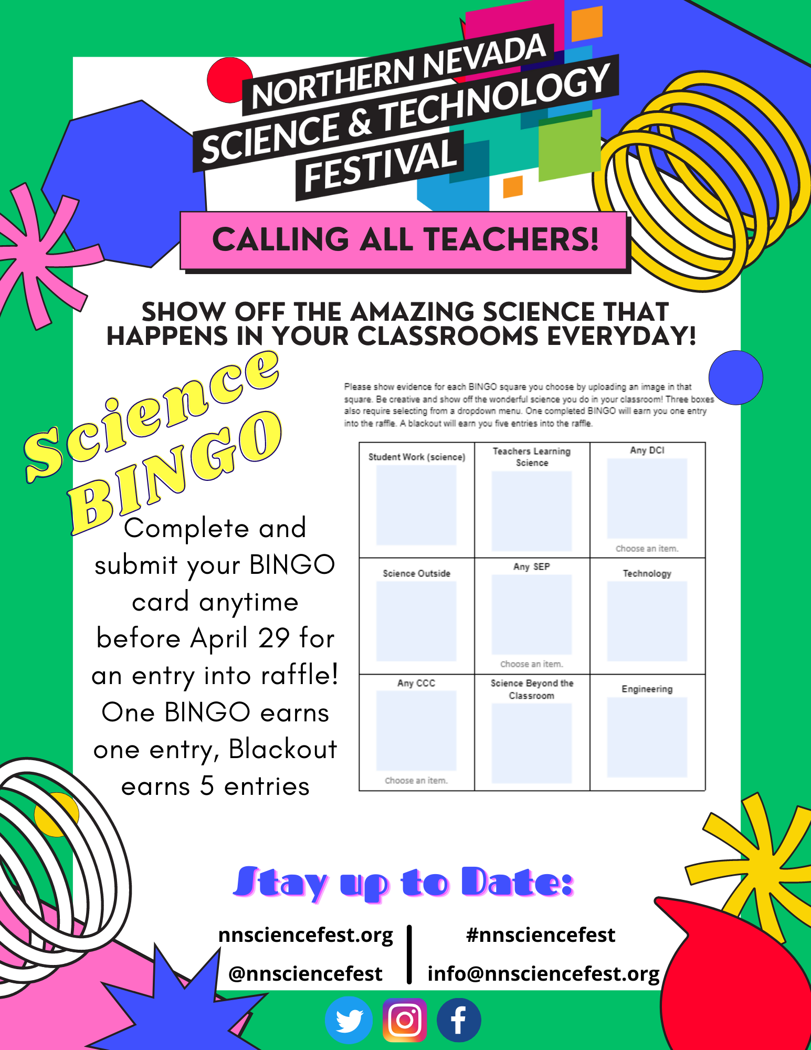
2023 Science in Schools BINGO Board

Please show evidence of the chosen BINGO squares by uploading an image in that square. Be creative and show the wonderful science you do in your classroom! Three boxes also require choosing from a dropdown menu. One completed BINGO will earn you one entry into the raffle. A blackout will earn you five entries into the raffle.

Student Work (science) | Teachers Learning Science | Any DCI  Choose an item.
Science Outside | Any SEP  Choose an item. | Technology
Any CCC  Choose an item. | Science Beyond the Classroom | Engineering

To submit your BINGO card, click HERE. Cards will be accepted anytime between now and April 29th, 2023. Winners will be announced the week of the Northern Nevada Science and Technology Festival, April 24th-29th, 2023

If you need ideas or suggestions of what images to add, please click HERE. If you have questions, please click HERE.

